Session 3 -1

import java.io.*;

public class Solution {

public static int marsExploration(String s) {
int alteredCount = 0;

// Loop through each character in the string
for (int i = 0; i < s.length(); i++) {
char currentChar = s.charAt(i);

// Check position in the "SOS" pattern (length 3)
if (i % 3 == 0 && currentChar != 'S') {
alteredCount++;
} else if (i % 3 == 1 && currentChar != 'O') {
alteredCount++;
} else if (i % 3 == 2 && currentChar != 'S') {
alteredCount++;
}
}

return alteredCount;
}

public static void main(String[] args) throws IOException {
BufferedReader bufferedReader = new BufferedReader(new InputStreamReader(System.in));

// Read the single input line containing string s
String s = bufferedReader.readLine().trim();

int result = marsExploration(s);
System.out.println(result);

bufferedReader.close();
}
}
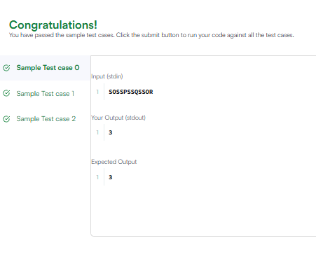

Session 3 -2

import java.util.ArrayList;
import java.util.Arrays;
import java.util.List;

public class Solution {
public List<Integer> findAnagrams(String s, String p) {
List<Integer> result = new ArrayList<>();

// Edge case: if s is shorter than p, an anagram cannot exist
if (s == null || p == null || s.length() < p.length()) {
return result;
}

int[] pCount = new int[26];
int[] sCount = new int[26];
int pLen = p.length();
int sLen = s.length();

// Build the base frequency for p and the first window of s
for (int i = 0; i < pLen; i++) {
pCount[p.charAt(i) - 'a']++;
sCount[s.charAt(i) - 'a']++;
}

// Check the very first window
if (Arrays.equals(pCount, sCount)) {
result.add(0);
}

// Slide the window across the rest of the string s
for (int i = pLen; i < sLen; i++) {
// Add the new character entering the window from the right
sCount[s.charAt(i) - 'a']++;

// Remove the old character leaving the window from the left
sCount[s.charAt(i - pLen) - 'a']--;

// If the frequencies match, add the start index of this window
if (Arrays.equals(pCount, sCount)) {
result.add(i - pLen + 1);
}
}

return result;
}
}
